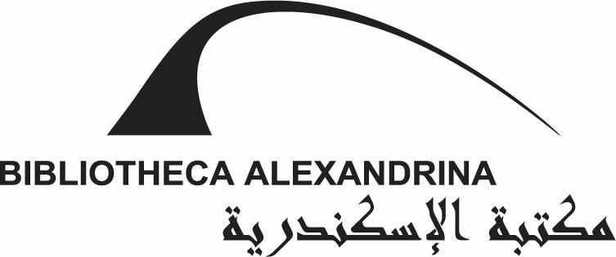

WORKSHOP APPLICATION FORM:

ARAB YOUTH CULTURE IN FLUX – THE TRANSFORMATIONAL POWER OF SOCIAL MEDIA
Name:
Address:
Telephone:
Email Address:
Age:
Education:
Occupation:

Please, answer the following questions either in English or in Arabic:

- Why are you interested in attending the social media workshop and what themes are you interested in discussing in the workshop?

- Which of the following social media tools do you frequently use? (Choose all that apply)
Twitter ___
Facebook ___
Google+ ___
LinkedIn ___
YouTube ___
Skype ___
MySpace ___
Flickr ___
WhatsApp ___
Other (please specify) :

- Which of the tools listed above do you use MOST often (at least weekly) to connect for social purposes? Choose max. 3.
Twitter ___
Facebook ___
Google+ ___
LinkedIn ___
YouTube ___
Skype ___
MySpace ___
Flickr ___
WhatsApp ___
Other (please specify) :

- Do you use your social media account(s) primarily to post information you want to share, or to see what others are posting?
I use it mostly to post information ___
I use it mostly to see what others are saying ___
It’s about half and half ___
I am not sure. ___

- Where do you use social media (at home, at workplace / university, in an Internet café etc.) and how (mobile phone, laptop, PC etc.)?

- Please, name five of your favourite Facebook groups.
1
2
3
4
5

- Social networking services (email, chatting etc.) enable individuals who share their activities and interests to find each other and to engage with each other in social activities. How do you think social networking services affect your social relationships?

- Are you politically active in social media? If yes, how and why?

- How do you think social media has affected Egypt’s politics in recent years?

- Nowadays social media are widely used by the Egyptian youth. What are the positive and what are the negative aspects of the usage of social media in the lives of young people in your opinion?

- Are you interested in participating the workshop Arab Youth Culture in Flux - The Transformational Power of Social Media in June 2013? One of the workshops will be held in English and the other one in Arabic. Which one would you like to participate?

Yes ___ (English workshop___ / Arabic workshop___)
No ___

I accept that my answers to the questions 1–10 can be stored to collect statistical information.

All the answers will be kept strictly confidential and never associated with your name.

Date:
Signature:

